Nik Collection: How and where to Download.

Nik Collection is a set of plugins that were developed to assist in photo editing.
Nik Collection can be installed and used in Photoshop or Lightroom and each of the Nik Collection plugins has its own purpose. Some plugins apply vintage filters while others enhance colour, sharpness or create beautiful black and white photos.
In this post, we cover how to download Nik Collection, how to get started and use a few of the most popular tools from this software to edit your photos.

How Much Is the Nik Collection?
Over the past few years, Nik Collection has been owned by a couple of different companies and the cost of Nik Collection has changed along with each new acquisition.
Currently, there are two Nik Collections available for download. The latest Nik Collection is owned by DxO and comes with 7 different plugins.
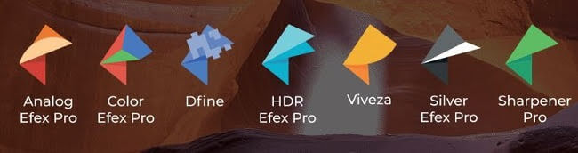

As of now, DxO offers a 30 day free trial of the Nik Collection so new users can check it out and get familiar with it.
After the 30-day trial, you will need to pay if you like the Nik editing software and want to continue using these plugins.

Before Nik Collection was acquired by DxO it was owned by Google and they offered a free version of the Nik Collection. If you’re interested in downloading the older free version, you can still do that.
Note that if you choose to use the older Google version, DxO does not offer customer service or support for this version. So if something isn’t compatible or doesn’t work right, unfortunately, you’re on your own. If you want software assistance, I recommend downloading the newer version which does cost but will come with DxO software assistance.

How to Download Nik Collection?
To download the latest Nik Collection you can go to the DxO Nik Collection website and click download.
It will ask for your email address which you can enter in the box and click “Submit”.
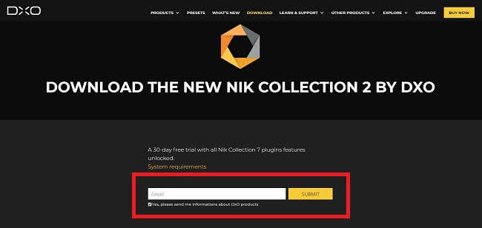

After entering your email address, you will receive a link in your inbox to download the Nik Collection software. Click on “Win” for Windows or “Mac”.
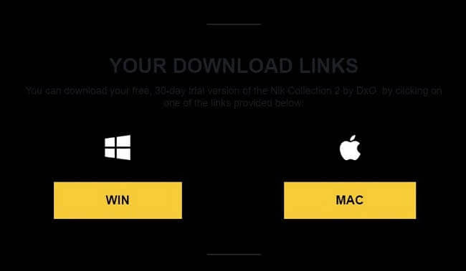

Once the software has downloaded a small icon will show up on the bottom left corner of your screen and you can click on this file icon to start the installation process.


If you don’t see the pop up on the bottom left corner, you can also go to your Downloads folder and click on Nik_Collection_2_byDXO file. This will launch the program setup.

The best part about Nik Collection is that it eliminates a lot of confusion and uncertainty when it comes to editing photos.
Sometimes Lightroom and Photoshop can feel so complicated because the editing choices seem endless. Nik Collection plugins eliminate most of the confusion and the program does all the hard work for you.

